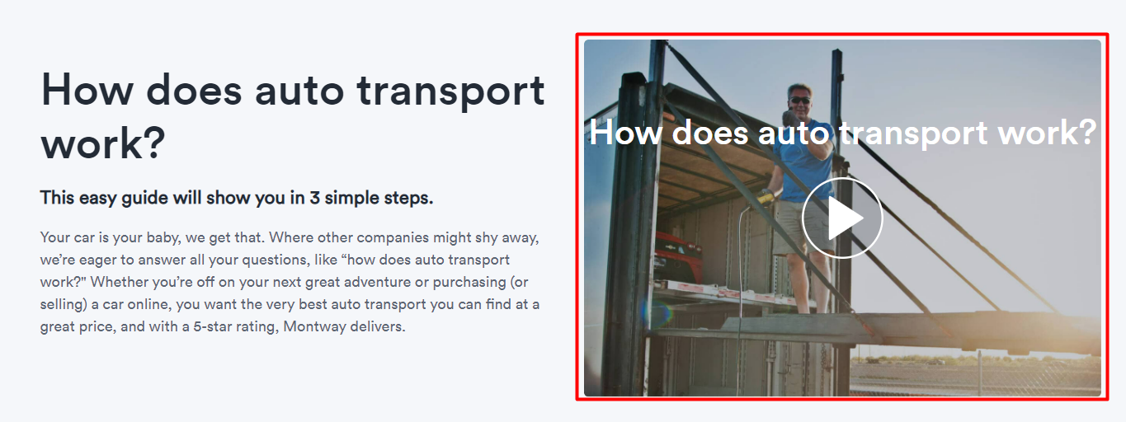

Yonboshiga video o’rniga manabu rasm quyiladi

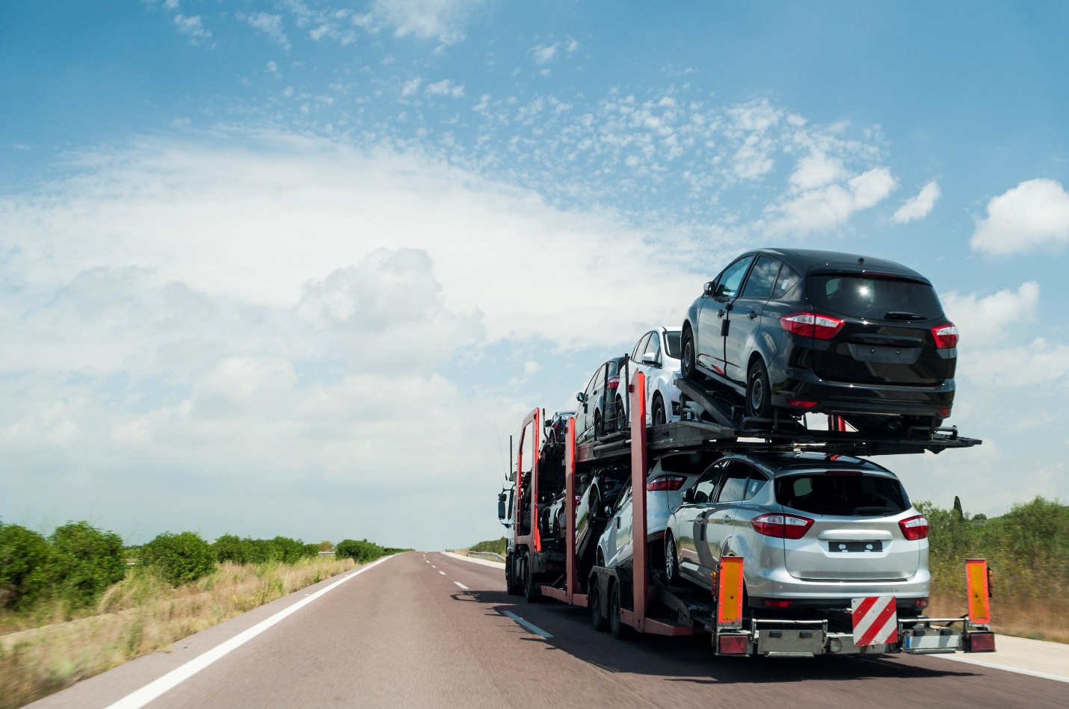

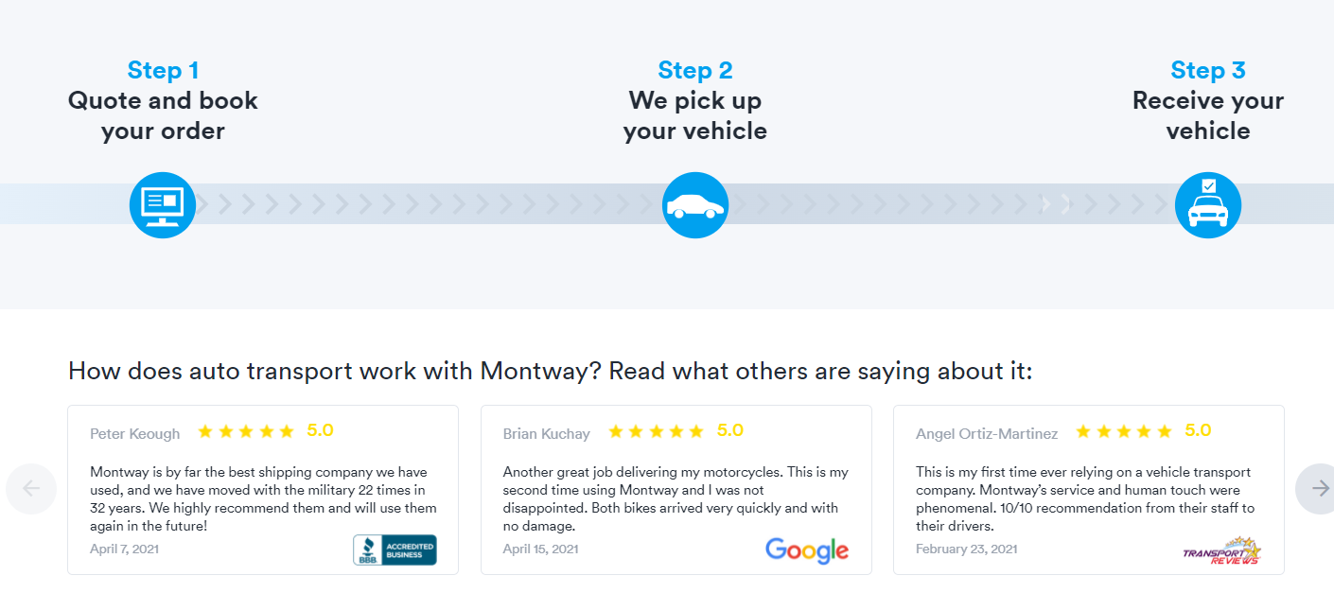

Pasti manabunday kurinishda buladi

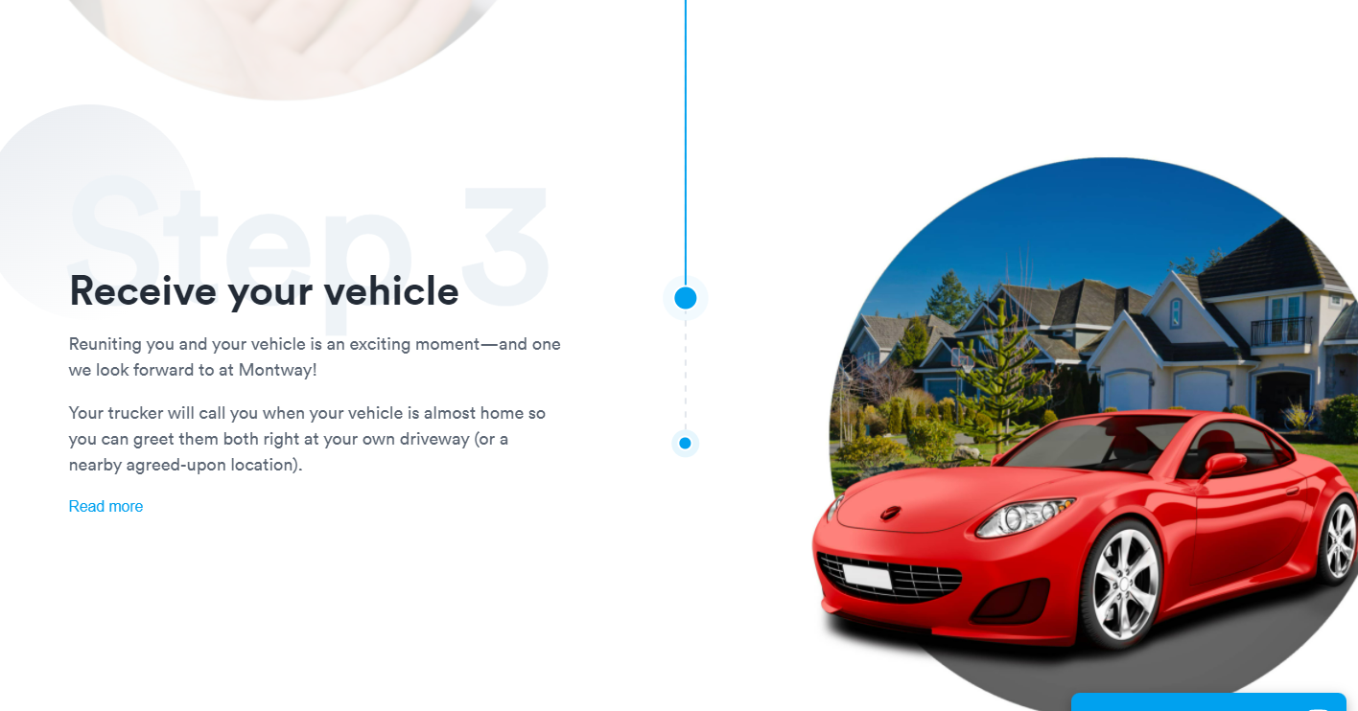

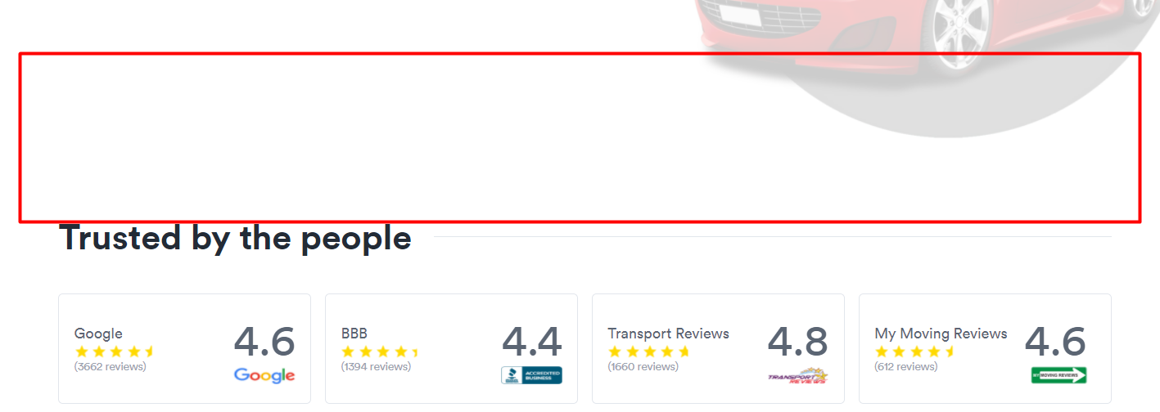

Keyin pastidan review platformalarni manabunday rasmi va tepasida quote tuldiradigan forma bo’lishi kerak. Uni yonboshidan manabu rasmni quyasiz

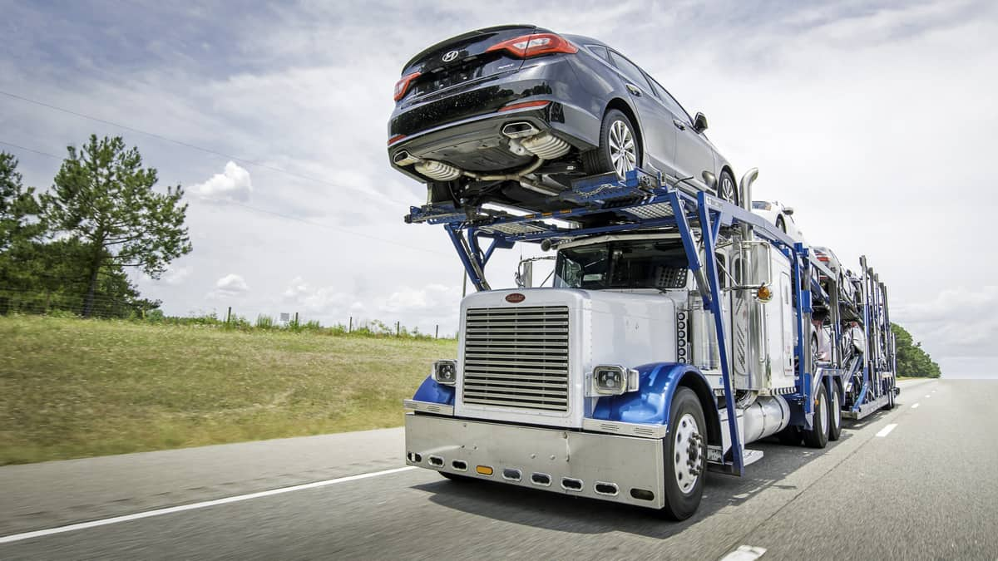

Animatsiyalari ham <https://www.montway.com/how-auto-transport-works> manashu linkdagidek bulsin iloji boricha.